**Explanation of Personalized item-based recommendation**

**Importing Necessary Libraries:**

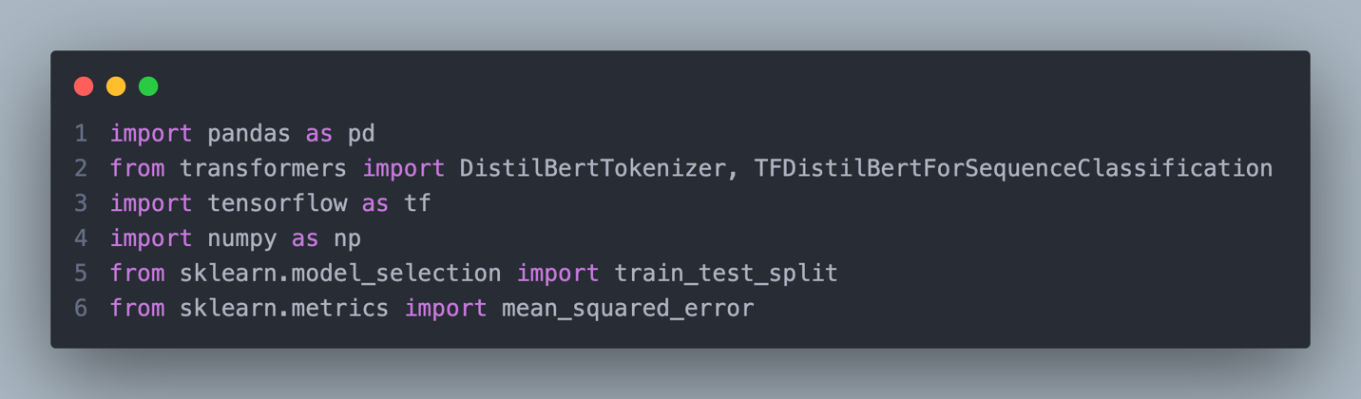

This kernel imports essential Python libraries for data processing, machine learning, and sequence classification:

* **pandas:** For data handling and manipulation.
* **transformers:** To use the pre-trained DistilBERT model for sequence classification.
* **tensorflow:** For building and training the deep learning model.
* **numpy:** For numerical computations.
* **sklearn:** For splitting datasets and calculating evaluation metrics like Mean Squared Error (MSE).

**Loading and Merging Data:**

**Loading Data:** The **Coles_cleaned.csv** and **updated_recommendation_dataset.csv** datasets are loaded into separate DataFrames.

**Merging Data:** The two datasets are merged on the **product_code** column to combine product details with user ratings.

**Identify Popular Products:**

* **Grouping:** Groups data by **product_code** and counts the number of ratings for each product.
* **Sorting:** Sorts products by the number of ratings in descending order to identify the most popular products.

**Utility Matrix Creation:**

* **Utility Matrix:** Creates a matrix where rows represent users, columns represent products, and cell values represent ratings.
* **Handling Missing Values:** Fills unrated items with 0 to ensure the matrix is complete.

**Tokenizing Product Names:**

* Defines a function to tokenize product names using the **DistilBERT** tokenizer.
* Tokenizes the **item_name_x** column from the merged dataset into tensors.

**Data Preparation for Model Training:**

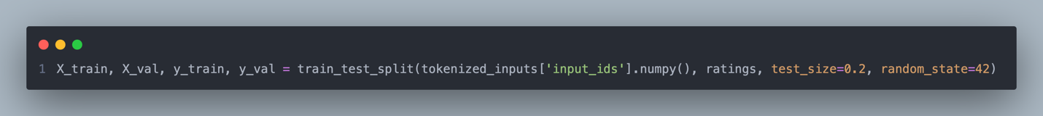

* Splits the tokenized input IDs and ratings into training and validation sets.

**Creating Datasets for TensorFlow:**

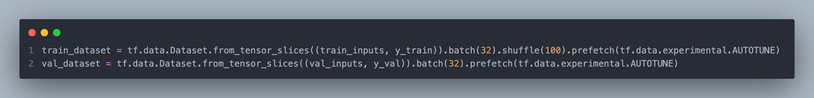

* Converts data into TensorFlow datasets for efficient model training and validation.
* Uses batching, shuffling, and prefetching to optimize performance.

**Training the DistilBERT Model:**

* Loads the **DistilBERT** model for sequence classification, configured to predict a single label (rating).
* Compiles the model with the Adam optimizer, MSE loss, and MAE as a metric.
* Trains the model on the training dataset with validation.

**Generating Predictions and Evaluation:**

* Generates predictions for the validation set.
* Evaluates model performance using Mean Squared Error (MSE).

**Predicting Ratings for all items:**

* Tokenizes all product names for prediction.
* Predicts ratings for all products using the trained model.
* Flattens the predicted ratings for consistency.

**Creating a DataFrame for Predictions:**

* Creates a DataFrame containing product details and their predicted ratings.

**Recommendation Function:**

* Predicts ratings for all products.
* Filters out products already purchased by the customer.
* Recommends the top-rated products for the customer based on the predicted ratings.

**Example Usage:**

* Generates personalized recommendations for a customer based on an input product.

This approach ensures an efficient and tailored recommendation system using a combination of NLP and deep learning.